**Java core Assignment – 1**

**TANAYA JADHAV**

**1)**

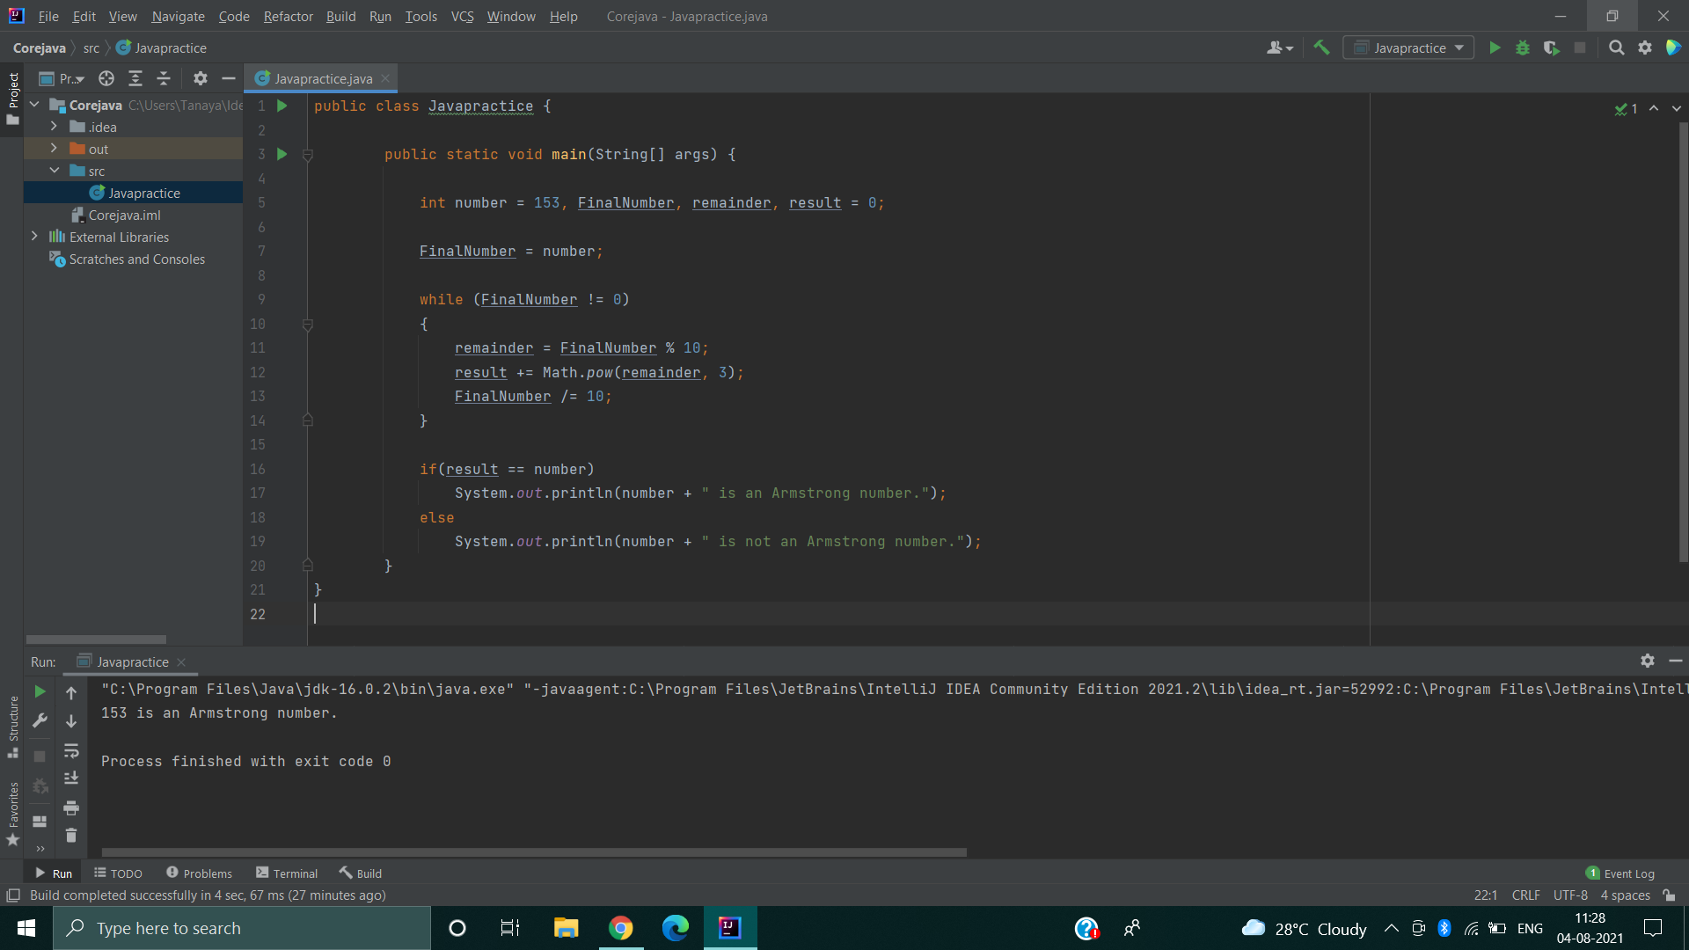

2)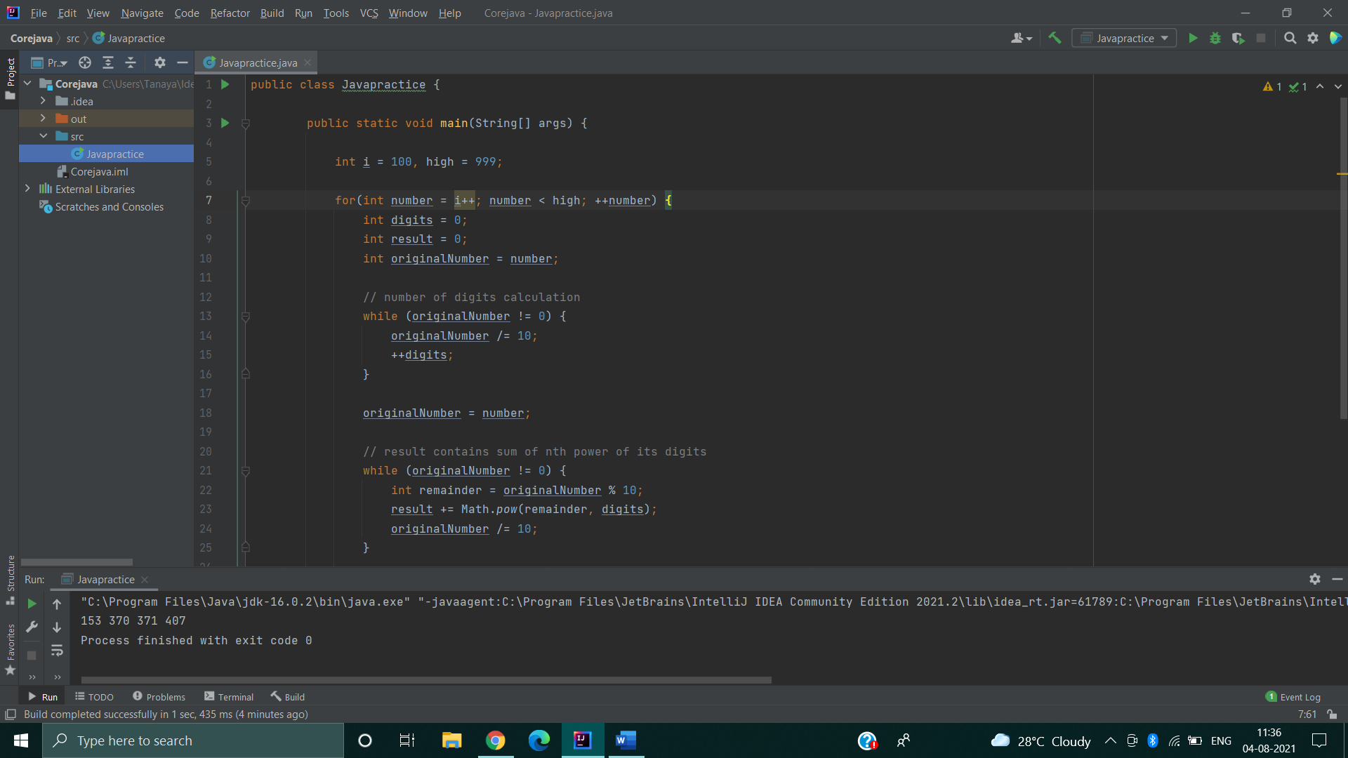

**3)**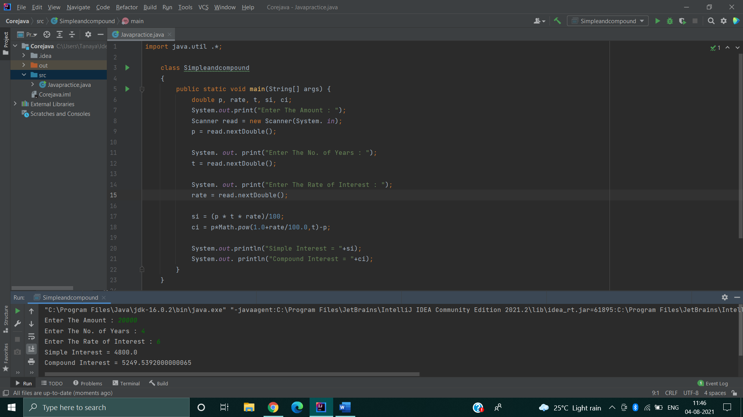

**4)Program code:**

Class javapractice

{  
  
 public static void main(String args[])  
  
 {  
  
 Scanner sc=new Scanner(System.*in*);  
  
 double a, b, c;  
  
 System.*out*.println("Enter your marks in three subjects...");  
  
 a=sc.nextDouble();  
  
 b=sc.nextDouble();  
  
 c=sc.nextDouble();  
  
 if(a>=60 && b>=60 && c>=60){  
  
 System.*out*.println("You passed the exam.");  
 }  
  
 else if(a>=60 && b>=60 && c<60){  
 System.*out*.println("You promoted the exam.");  
 }  
  
 else  
  
 System.*out*.println("You have failed. Hard work is needed. ");  
  
 }  
  
}

Output:

"C:\Program Files\Java\jdk-16.0.2\bin\java.exe" "-javaagent:C:\Program Files\JetBrains\IntelliJ IDEA Community Edition 2021.2\lib\idea_rt.jar=52373:C:\Program Files\JetBrains\IntelliJ IDEA Community Edition 2021.2\bin" -Dfile.encoding=UTF-8 -classpath C:\Users\Tanaya\IdeaProjects\Corejava\out\production\Corejava javapractice

Enter your marks in three subjects...

78

96

85

You passed the exam.

Process finished with exit code 0

"C:\Program Files\Java\jdk-16.0.2\bin\java.exe" "-javaagent:C:\Program Files\JetBrains\IntelliJ IDEA Community Edition 2021.2\lib\idea_rt.jar=52911:C:\Program Files\JetBrains\IntelliJ IDEA Community Edition 2021.2\bin" -Dfile.encoding=UTF-8 -classpath C:\Users\Tanaya\IdeaProjects\Corejava\out\production\Corejava javapractice

Enter your marks in three subjects...

78

23

41

You have failed. Hard work is needed.

Process finished with exit code 0

Enter your marks in three subjects...

60

60

41

You promoted the exam.

Process finished with exit code 0

**5)program code: -**

5) import java.util.Scanner;  
  
class javapractice  
{  
 public static void main(String args[])  
 {  
 double tax=0,ctc,sum;  
 Scanner sc=new Scanner(System.*in*);  
 System.*out*.println("Enter income ");  
 ctc=sc.nextDouble();  
 if(ctc<=180000){  
 tax = 0;  
 }  
 else if((ctc>=181001)&&(ctc<=300000)) {  
 tax = 10;  
 sum = (tax / 100) * ctc;  
 System.*out*.println("Tax amount " + sum);  
 }  
 else if((ctc>=300001)&&(ctc<=500000)){  
 tax = 20;  
 sum = (tax / 100) * ctc;  
 System.*out*.println("Tax amount " + sum);  
 }  
 else if((ctc>=500001)&&(ctc<=1000000)){  
 tax = 30;  
 sum = (tax / 100) * ctc;  
 System.*out*.println("Tax amount " + sum);  
 }  
 }  
}

"C:\Program Files\Java\jdk-16.0.2\bin\java.exe" "-javaagent:C:\Program Files\JetBrains\IntelliJ IDEA Community Edition 2021.2\lib\idea_rt.jar=57528:C:\Program Files\JetBrains\IntelliJ IDEA Community Edition 2021.2\bin" -Dfile.encoding=UTF-8 -classpath C:\Users\Tanaya\IdeaProjects\Corejava\out\production\Corejava javapractice

Enter income

548941

Tax amount 164682.3

Process finished with exit code 0

6)Program code:-

import java.util.Scanner;  
  
class javapractice {  
 public static void main(String[] args) {  
 Scanner sc = new Scanner(System.*in*);  
 String sp = " ";  
 System.*out*.println("Enter the login name");  
 String uname = sc.nextLine();  
  
 System.*out*.println("Enter the Password");  
 String upass = sc.nextLine();  
  
  
 System.*out*.println(uname + " you are Registered Successfully");  
  
 System.*out*.println("Enter the Username");  
 String lname = sc.nextLine();  
 System.*out*.println("Enter the Password");  
 String lpass = sc.nextLine();  
  
 if (uname.equals(lname) && upass.equals(lpass)) {  
 System.*out*.println("Welcome " + lname + " you have Logged-in Successfully");  
 } else {  
 System.*out*.println("Username or password Mismatch");  
 }  
 int totalAttempts = 3;  
  
 while (totalAttempts != 0) {  
  
 if (lname == "temp" && lpass == "pass") {  
  
  
 System.*out*.println("Login Correct!");  
 return;  
  
 } else {  
  
  
 System.*out*.println("Incorrect Login");  
  
 totalAttempts--;  
 System.*out*.println(totalAttempts);  
  
 }  
  
 }  
  
 if (totalAttempts == 0) {  
  
 System.*out*.println("Maximum number of attempts exceeded,,CONTACT ADMIN");  
 }  
 }  
}

output:

"C:\Program Files\Java\jdk-16.0.2\bin\java.exe" "-javaagent:C:\Program Files\JetBrains\IntelliJ IDEA Community Edition 2021.2\lib\idea_rt.jar=55244:C:\Program Files\JetBrains\IntelliJ IDEA Community Edition 2021.2\bin" -Dfile.encoding=UTF-8 -classpath C:\Users\Tanaya\IdeaProjects\Corejava\out\production\Corejava javapractice

Enter the login name

TANAYA

Enter the Password

123

TANAYA you are Registered Successfully

Enter the Username

TANAYA

Enter the Password

123

Welcome TANAYA you have Logged-in Successfully

Incorrect Login

2

Incorrect Login

1

Incorrect Login

0

Maximum number of attempts exceeded,,CONTACT ADMIN

Process finished with exit code 0

code 0

7)Program code:-

import java.util.*;  
  
class javapractice  
{  
 public static void main(String args[])  
 {  
 Scanner sc = new Scanner(System.*in*);  
  
 int i,n,search,temp=0;  
 System.*out*.println("Enter the array size:") ;  
 n = sc.nextInt();  
 int[] a = new int[n];  
  
 System.*out*.println("Enter the elements:") ;  
 for(i=0;i<n;i++)  
 {  
 a[i] = sc.nextInt();  
 }  
  
 System.*out*.println("what you wanna search?");  
 search = sc.nextInt();  
 for(i=0;i<n;i++)  
 {  
 if(a[i]==search)  
 {  
 System.*out*.println("Element "+search+" found at "+i+" position");  
 temp=1;  
 break;  
 }  
 }  
 if(temp==0)  
 {  
 System.*out*.println("Element "+search+" not found");  
 }  
 }  
}

Output:

"C:\Program Files\Java\jdk-16.0.2\bin\java.exe" "-javaagent:C:\Program Files\JetBrains\IntelliJ IDEA Community Edition 2021.2\lib\idea_rt.jar=64794:C:\Program Files\JetBrains\IntelliJ IDEA Community Edition 2021.2\bin" -Dfile.encoding=UTF-8 -classpath C:\Users\Tanaya\IdeaProjects\Corejava\out\production\Corejava javapractice

Enter the array size:

15

Enter the elements:

5

12

14

6

78

19

1

23

26

35

37

7

52

86

47

what you wanna search?

19

Element 19 found at 5 position

Process finished with exit code 0

**8)Program code: -**

public class BubbleSort {  
 void bubbleSort(int arr[])  
 {  
 int n = arr.length;  
 for (int i = 0; i < n-1; i++)  
 for (int j = 0; j < n-i-1; j++)  
 if (arr[j] > arr[j+1])  
 {  
 int temp = arr[j];  
 arr[j] = arr[j+1];  
 arr[j+1] = temp;  
 }  
 }  
  
 void printArray(int arr[])  
 {  
 int n = arr.length;  
 for (int i=0; i<n; ++i)  
 System.*out*.print(arr[i] + " ");  
 System.*out*.println();  
 }  
  
 public static void main(String args[])  
 {  
 BubbleSort ob = new BubbleSort();  
 int arr[] = {5, 12, 14, 6, 78, 19, 1, 23, 26, 35, 37, 7, 52, 86, 47};  
 ob.bubbleSort(arr);  
 System.*out*.println("Tanaya,,,Sorted array");  
 ob.printArray(arr);  
 }  
}

Output:-

"C:\Program Files\Java\jdk-16.0.2\bin\java.exe" "-javaagent:C:\Program Files\JetBrains\IntelliJ IDEA Community Edition 2021.2\lib\idea_rt.jar=61508:C:\Program Files\JetBrains\IntelliJ IDEA Community Edition 2021.2\bin" -Dfile.encoding=UTF-8 -classpath C:\Users\Tanaya\IdeaProjects\Corejava\out\production\Corejava BubbleSort

Tanaya,,,Sorted array

1 5 6 7 12 14 19 23 26 35 37 47 52 78 86

Process finished with exit code 0

**9) Program code:-**

import java.util.Scanner;  
  
public class StudentMarksAvg  
{  
 public static void main(String args[]) {  
 Scanner in = new Scanner(System.*in*);  
 System.*out*.print("Enter number of students: ");  
 int n = in.nextInt();  
  
 String name[] = new String[n];  
 int subject[] = new int[n];  
 int totalmarks[] = new int[n];  
 int grandTotal = 0;  
  
 for (int i = 0; i < n; i++) {  
 in.nextLine();  
 System.*out*.print("Enter name of student " + (i+1) + ": ");  
 name[i] = in.nextLine();  
 System.*out*.print("Enter no of subject he scored " + (i+1) + ": ");  
 subject[i] = in.nextInt();  
 System.*out*.print("Enter total marks of student " + (i+1) + ": ");  
 totalmarks[i] = in.nextInt();  
 grandTotal += totalmarks[i];  
 }  
  
 double avg = grandTotal / (double)n;  
 System.*out*.println("Average = " + avg);  
  
 for (int i = 0; i < n; i++) {  
 final int i1 = (totalmarks[i]) / 3;  
 System.*out*.println("Total of marks entered by is " + name[i] + " "  
 + (totalmarks[i])+" Average is " +i1);  
 }  
 }  
}

Output:

"C:\Program Files\Java\jdk-16.0.2\bin\java.exe" "-javaagent:C:\Program Files\JetBrains\IntelliJ IDEA Community Edition 2021.2\lib\idea_rt.jar=60203:C:\Program Files\JetBrains\IntelliJ IDEA Community Edition 2021.2\bin" -Dfile.encoding=UTF-8 -classpath C:\Users\Tanaya\IdeaProjects\Corejava\out\production\Corejava StudentMarksAvg

Enter number of students: 3

Enter name of student 1: tanaya

Enter no of subject he scored 1: 3

Enter total marks of student 1: 800

Enter name of student 2: amit

Enter no of subject he scored 2: 3

Enter total marks of student 2: 900

Enter name of student 3: sam

Enter no of subject he scored 3: 3

Enter total marks of student 3: 789

Average = 829.6666666666666

Total of marks entered by is tanaya 800 Average is 266

Total of marks entered by is amit 900 Average is 300

Total of marks entered by is sam 789 Average is 263

Process finished with exit code 0